DAY 6 – 16.04.2024

1. OUTPUT SCREENSHOT FOR CLASS ACCENTURE

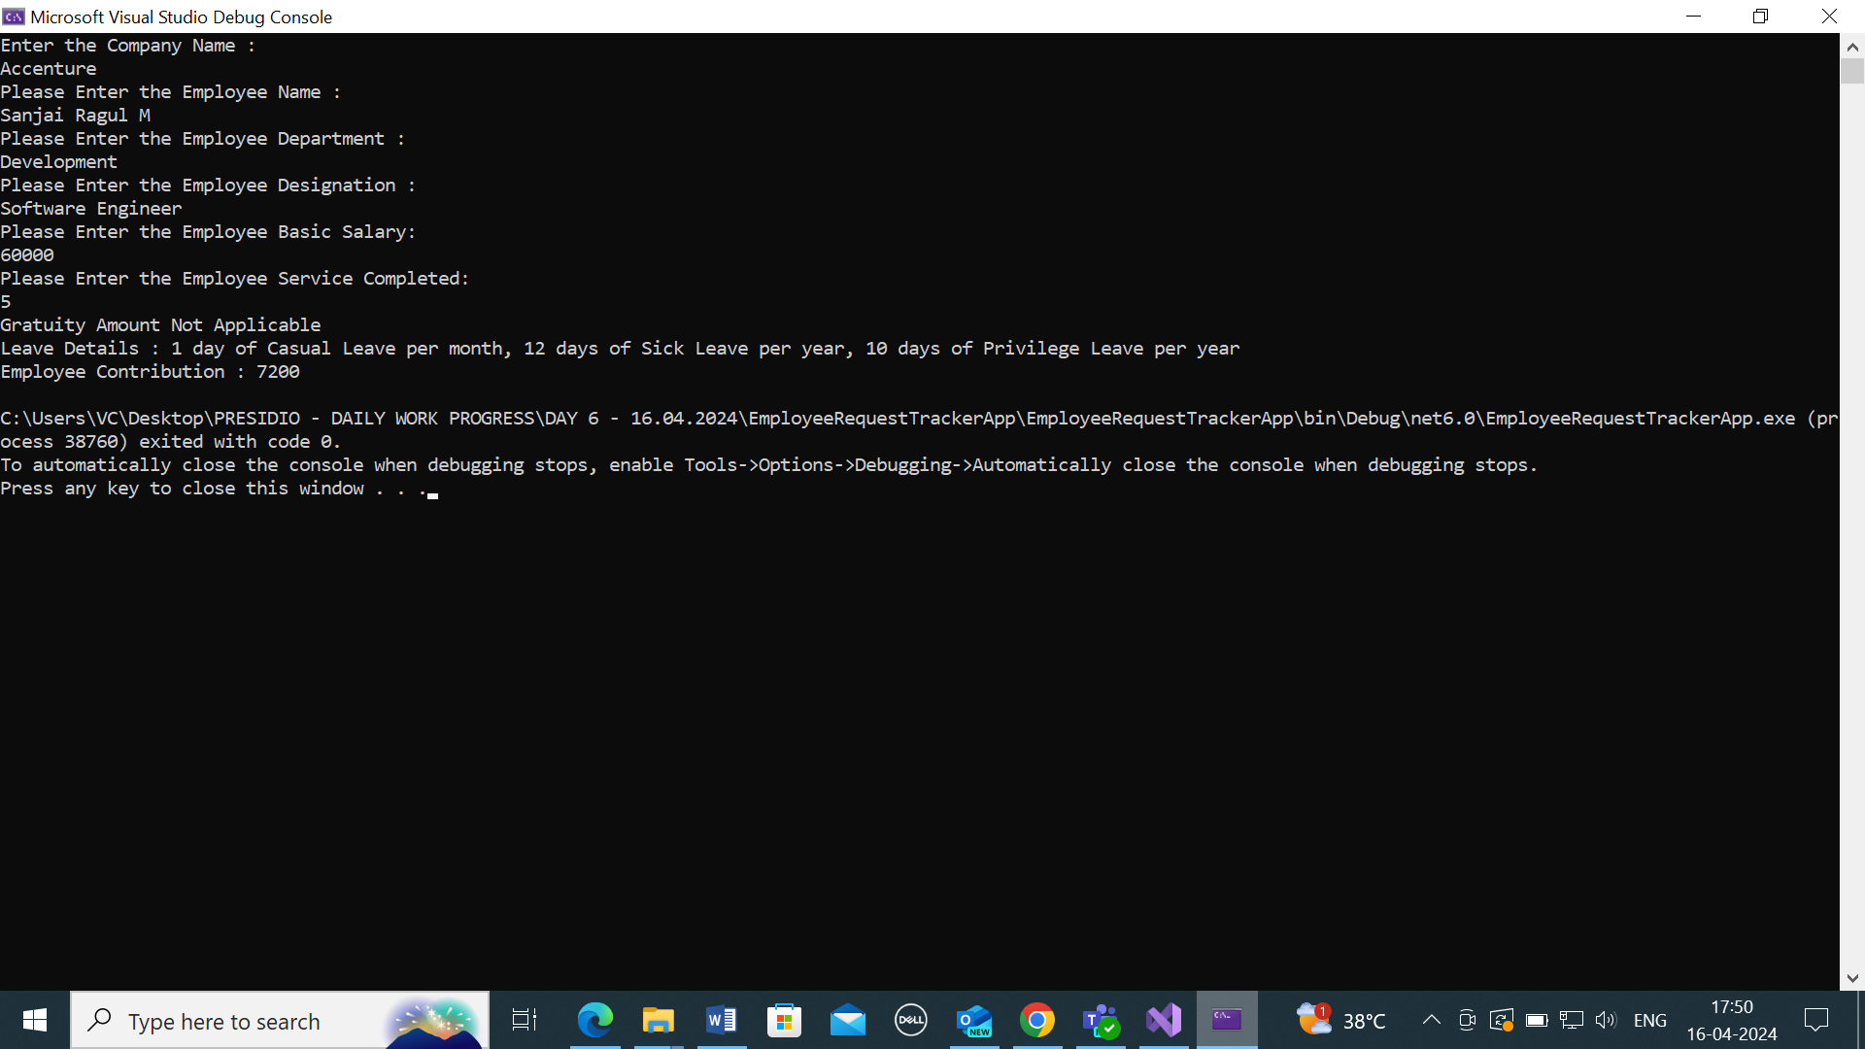

1. OUTPUT SCREENSHOT FOR CLASS CTS

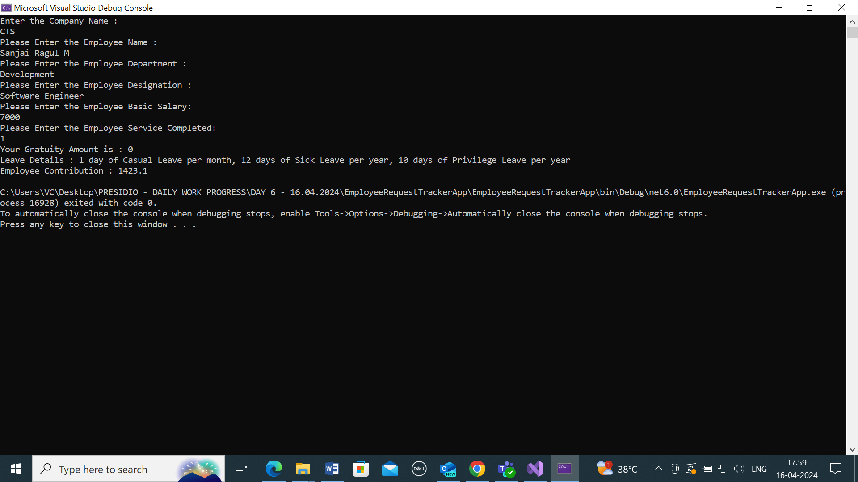

ENCAPSULATION AND INHERITANCE:

